

DEVELOPMENT OF A SECURE E-VOTING SYSTEM

SCT222-0250/2021
RONALD KEAH ZANI

A Final Research submitted to the Department of Information Technology (IT) in the School of Computing and Information Technology (IT) in partial fulfillment of the requirement for the award of the degree of Bachelor of Science in Business Computing of the Jomo Kenyatta University of Agriculture and Technology.

DECLARATION

This proposal is my original work and has not been presented for a degree in any other University.
……………………… ………………………..
Signature Date
Zani Ronald Keah

This proposal has been submitted for examination with my approval as University Supervisor.
………………….. …………………………
Signature Date
Madam Esther Mukoya

LIST OF ABBREVIATIONS

- AI – Artificial Intelligence
- ML – Machine Learning
- DL – Deep Learning
- IoT – Internet of Things
- CPU – Central Processing Unit
- GPU – Graphics Processing Unit
- RNN – Recurrent Neural Network
- CNN – Convolutional Neural Network
- NLP – Natural Language Processing
- API – Application Programming Interface
- SQL – Structured Query Language
- JSON – JavaScript Object Notation

TABLE OF CONTENTS
DECLARATION ii
LIST OF ABBREVIATIONS iii
LIST OF TABLES vii
LIST OF FIGURES viii
ABSTRACT ix
CHAPTER ONE 1
INTRODUCTION 1
1.1 Background 2
1.2 Problem Statement 3
1.3 Proposed Solution 3
1.4 Objectives to Study 5
1.4.1 General Objectives 5
1.4.2 Specific Objectives 5
1.5 Research Questions 5
1.6 Justification 6
1.7 Scope 7
1.8 Proposed Methodology 8
1.8.1 Research Methodology 8
1.8.2 System Methodology 9
CHAPTER TWO 12
LITERATURE REVIEW 12
2.1 Introduction 12
2.2 Theoretical Review and Conceptual Framework 12
2.2.1 Cybersecurity in E-Voting Systems 12
2.2.2 Accessibility in E-Voting Systems 13
2.2.3 Usability and User Trust in E-Voting Systems 14
2.3 Conceptual Framework 14
2.4 Critique of Existing Literature 15
2.5 Summary 17
2.6 Research Gaps 18
CHAPTER 3: 20
SYSTEM ANALYSIS AND DESIGN 20
3.1 Introduction 20
3.2 System Development Methodology 21
3.3 Feasibility Study 22
3.3.1 Technical Feasibility 22
3.3.2 Economic Feasibility 23
3.3.3 Operational Feasibility 24
3.4 Requirement Elicitation 26
3.4 Data and System Analysis 26
3.4.1 Data Analysis 26
3.4.2 System Analysis 32
3.5 System Specification 33
3.6 Logical Design 35
3.6.1 System Architecture (System Tiers and Components) 36
3.6.2 Class Diagram (Data Organization and Relationships) 38
3.6.3 Data Flow Diagrams (Information Flow in the System) 40
3.6.4 Use Case Diagram 43
3.6.5 Entity-Relationship Diagram (ERD) 44
CHAPTER 4 47
SYSTEM IMPLEMENTATION AND TESTING 47
4.1 Introduction 47
4.2 Development Environment And Tools Used 47
4.3 System Architecture 48
4.4 Testing 52
4.4.1 Types of Testing 52
4.4.2 Test Cases and Reports 52
4.5 Project Appraisal 53
4.5.1 Limitations 53
4.5.2 Strengths 53
4.6 Conclusions and Recommendations 54
4.6.1 Conclusions 54
4.6.2 Recommendations 54
REFERENCES 56
APPENDICES 58
Appendix I: Project Budget 58
Appendix II: Project Timeline 58
Appendix III: Project Timeline Gant Chart 60
Appendix IV: Questionnaires 60
Appendix V: Interviews 61
Appendix VI: Observation 61

LIST OF TABLES
Table 1:Economical Feasibility Breakdown 23
Table 2:Expected Benefits of Economic Feasibility 24
Table 4:Functionality 48
Table 5: Test Case and Reports 52
Table 6:Project Budget 58
Table 7:Project Timeline 58

LIST OF FIGURES
Figure 1:System Methodology Diagram 11
Figure 2:Conceptual Diagram 15
Figure 3: User Feedback from Questionnaire 27
Figure 4: Age Group Response 28
Figure 5: Gender Response 28
Figure 6: Level of Education Response 29
Figure 7: People who voted in the previous Election 29
Figure 8: Ratio experience of the Tradition Voting System 30
Figure 9: Concern of Security of the Current System 30
Figure 10: Importance of Transparency 31
Figure 11: Comfortability of using Technology 31
Figure 12: Willingness of using Electronic-Voting System 32
Figure 13:System Architecture Diagram 38
Figure 14:Class Diagram 39
Figure 15:DFD Level 0 41
Figure 16:DFD Level 1 42
Figure 17:Use-case Diagram 44
Figure 18:ER-Diagram 46
Figure 19:Homepage 49
Figure 20:Homepage code 49
Figure 21:Registration page 50
Figure 22:Registration code 50
Figure 23:Login page 51
Figure 24:Login code 51
Figure 25:Project Timeline Chart 60

ABSTRACT
The integrity, transparency, and efficiency of electoral processes are critical to the stability of democratic societies. Traditional paper-based voting systems, while familiar, are increasingly prone to issues such as delayed result transmission, voter fraud, and limited accessibility for marginalized populations. This project presents the development of a secure and accessible web-based electronic voting (E-voting) system tailored for the Independent Electoral and Boundaries Commission (IEBC). The system leverages cybersecurity best practices including secure authentication, data encryption, and protected session handling to safeguard the confidentiality and integrity of votes. Additionally, it emphasizes inclusivity by incorporating accessibility features that cater to users with disabilities and those in remote regions. Through a combination of system design, implementation, and evaluation, the project aims to demonstrate a more efficient, secure, and user-friendly approach to electronic voting in Kenya.

CHAPTER ONE

INTRODUCTION
Elections form the backbone of democratic governance, enabling citizens to actively participate in the decision-making process. As the world becomes increasingly digital, countries are exploring electronic voting (E-voting) as a modern solution to enhance election transparency, efficiency, and accessibility. E-voting systems hold the promise of speeding up the voting process, ensuring more accurate results, and providing a more inclusive voting experience for populations with specific needs. However, the transition to digital voting brings with it several securities, legal, and technical challenges that need to be addressed to build public trust.
Global Perspective: E-voting Adoption and Challenges
Globally, countries have made significant strides in implementing E-voting systems, though the results have been mixed. Estonia serves as a leading example, where internet-based voting has been successfully implemented since 2005. With over 30% of the population participating in online voting, Estonia has set a benchmark for how digital elections can be efficiently conducted (Vassil et al., 2016). On the other hand, nations like the United States have faced difficulties in adopting E-voting due to concerns over cybersecurity and privacy. In particular, the 2016 U.S. Presidential Election revealed vulnerabilities in election infrastructure, with cyberattacks targeting voting systems and allegations of foreign interference (Adida et al., 2008). As such, while many countries are eager to embrace digital voting, concerns around data integrity, hacking threats, and public trust remain key barriers to global E-voting adoption.
Local (Kenyan) Perspective: The Need for E-voting and Electoral Challenges
In Kenya, the adoption of technology by the Independent Electoral and Boundaries Commission (IEBC) has been gradual. While innovations such as biometric voter registration and electronic result transmission have been implemented, the core voting process still relies on traditional paper ballots. This has contributed to significant challenges, such as vote tampering, delayed results, and limited accessibility for people with disabilities or those living in remote areas. Kenya's 2017 elections were marred by accusations of irregularities and election manipulation, leading to widespread public mistrust (Okello & Obala, 2018). Furthermore, accessibility remains a critical issue, as voters in rural areas often face difficulties in reaching polling stations, and persons with disabilities struggle with inadequate support at voting booths. Given these issues, the introduction of a secure and accessible E-voting system could provide a solution by ensuring voter anonymity, enhancing accessibility, and speeding up the electoral process.

1.1 Background
Elections are fundamental to democratic societies, providing a structured mechanism for citizens to express their will and participate in governance. As technology advances, many nations are exploring more efficient and transparent electoral processes through electronic voting (E-voting). A well-designed E-voting system has the potential to improve security, reduce election-related violence, and ensure accurate vote tallying. However, these benefits can only be realized if the system is secure, inclusive, and trustworthy.
Global Perspective
Globally, countries like Estonia and Brazil have led the way in adopting E-voting technologies. Estonia introduced internet-based voting in 2005, and it remains one of the most cited examples of secure, large-scale online voting implementation (Vassil et al., 2016). Similarly, Brazil has long relied on electronic voting machines (EVMs) to conduct nationwide elections, which has significantly reduced vote-counting time and minimized human error (de Araujo et al., 2020). Despite these advancements, global challenges remain cyberattacks, data manipulation, and public mistrust are serious concerns that can compromise the credibility of the electoral process (Adida et al., 2008).
Local (Kenyan) Perspective
In Kenya, the Independent Electoral and Boundaries Commission (IEBC) is responsible for managing elections. While the IEBC has introduced technologies such as biometric voter registration and electronic result transmission, the core voting process still relies heavily on manual systems. This has led to concerns over vote rigging, result delays, and accessibility limitations, especially in rural areas and among persons with disabilities (Okello & Obala, 2018). Moreover, mistrust in election outcomes has, in some instances, contributed to political tension and post-election violence.
With Kenya’s increasing internet penetration and mobile phone usage, there is a growing opportunity to transition to a more robust, secure, and inclusive E-voting solution. However, to gain public trust, such a system must be designed with strong cybersecurity safeguards and a focus on accessibility for all eligible voters.

1.2 Problem Statement
Kenya’s current electoral system faces significant challenges in ensuring efficiency, transparency, and accessibility. Despite the introduction of technological solutions like biometric voter registration and electronic result transmission, the reliance on paper ballots and manual counting continues to expose the process to errors, delays, and potential manipulation (Okello & Obala, 2018). The 2017 elections highlighted these weaknesses, with accusations of irregularities and a lack of transparency undermining public trust (Okello & Obala, 2018). Additionally, the traditional voting system remains inaccessible to certain groups, including rural voters and those with disabilities, limiting their ability to participate fully in the electoral process.
Furthermore, cybersecurity risks associated with electronic voting have emerged as a global concern. Countries such as the United States have faced issues with election interference and hacking attempts, highlighting vulnerabilities that Kenya must address as it considers transitioning to a digital voting system (Adida et al., 2008).
There is, therefore, an urgent need for the development of a secure, transparent, and accessible E-voting system that addresses these challenges. Such a system must incorporate advanced cybersecurity measures to protect voter data, ensure accuracy in vote tallying, and provide an inclusive platform for all citizens to participate in the electoral process, regardless of their location or physical ability.

1.3 Proposed Solution
To address the identified challenges within Kenya's electoral system, this project proposes the development of a secure, transparent, and accessible web-based E-voting system. This solution aims to enhance the electoral process by incorporating advanced cybersecurity measures, improving voter accessibility, and ensuring system reliability.
Key Features of the Proposed E-voting System:
- Security and Data Integrity
  - The proposed system will incorporate end-to-end encryption to ensure that all votes are securely transmitted and protected from tampering. This will ensure that voter data remains confidential and that no unauthorized access can alter the results. Additionally, the system will employ multi-factor authentication to verify the identity of voters, preventing fraud and ensuring that only eligible individuals can cast their ballots.
- Transparency and Trust
  - To address concerns about electoral transparency, the system will implement blockchain-based auditing mechanisms. This will allow for real-time, tamper-proof verification of votes and results, providing both the public and electoral officials with confidence in the system's accuracy. Voters will also receive digital receipts confirming their vote, allowing them to verify their participation and ensuring auditability throughout the election process.
- Accessibility for All Voters
  - The system will be designed with user accessibility as a core principle. It will feature an intuitive interface that accommodates individuals with varying levels of digital literacy, as well as enhanced accessibility features such as screen readers and large fonts for persons with disabilities. Additionally, the system will be mobile-friendly, enabling users in remote areas with limited access to computers to vote via smartphones, thereby increasing voter participation.
- Real-time Results and Efficiency
  - With electronic voting, the time taken to count votes and announce results will be drastically reduced. The system will automatically tally votes, ensuring faster and more accurate results, minimizing human error, and reducing the potential for disputes. This will enhance the overall efficiency of the election process, allowing for quicker finalization of election outcomes.
- Scalability and Adaptability
  - The system will be scalable, designed to handle a large number of voters without compromising performance. It will also be adaptable to future electoral needs, supporting multiple election types, including local, national, and referenda elections, and allowing for system updates to keep pace with evolving technology and security requirements.
Conclusion
By implementing a secure, accessible, and transparent E-voting system, Kenya can modernize its electoral process, reduce the risks associated with manual voting, and ensure that every eligible voter has an equal opportunity to participate in the democratic process. The proposed system aims to foster greater public trust in the electoral process, improve efficiency, and ensure that the elections are free from manipulation and fraud.

1.4 Objectives to Study

1.4.1 General Objectives
To develop a secure, transparent, and accessible web-based E-voting system that addresses the challenges of accessibility, and trust, aimed at improving the electoral process in Kenya.

1.4.2 Specific Objectives

- To design and implement a secure voting framework that integrates advanced cybersecurity measures such as end-to-end encryption, multi-factor authentication, and data protection protocols to ensure the integrity and confidentiality of the voting process within 8 months.
- To develop an intuitive and accessible user interface that accommodates individuals with disabilities and is optimized for mobile devices, ensuring that at least 90% of test users can successfully vote in a simulated environment within 6 months.
- To automate the vote tallying process, reducing the time taken to count and announce election results by at least 50% compared to traditional methods, with a functional demo ready for pilot testing within 7 months.

1.5 Research Questions
- How can advanced cybersecurity measures, such as end-to-end encryption and multi-factor authentication, be integrated into the E-voting system to ensure the integrity, confidentiality, and security of the voting process?
- What are the best practices for designing an intuitive and accessible user interface that accommodates individuals with disabilities and is mobile-friendly, ensuring high success rates in the voting process?
- How can role-based access control and audit logging be implemented in the E-voting system to enhance accountability, prevent unauthorized actions, and support system transparency?

1.6 Justification
The need for secure, transparent, and accessible voting systems has become increasingly critical in democratic processes globally. Traditional voting methods, which heavily rely on paper ballots and manual counting, often face challenges such as voter fraud, delayed results, and inaccurate vote tallying. In many cases, these systems are also inaccessible to certain groups, such as people with disabilities and those living in rural or remote areas, thereby limiting voter participation and potentially skewing election outcomes (Okello & Obala, 2018). In light of these issues, transitioning to an E-voting system offers significant advantages that can improve the election process in Kenya and globally.
1. Security and Integrity of the Electoral Process
One of the primary challenges facing traditional elections is ensuring the security and integrity of the voting process. Cybersecurity concerns, including vote tampering and data breaches, are critical issues that need to be addressed to ensure trust in the electoral system (Adida et al., 2008). A secure E-voting system can integrate measures such as end-to-end encryption, multi-factor authentication, and data protection protocols, all of which would protect the integrity of votes from malicious interference, ensuring that each vote is accurately counted and transmitted securely. As evidenced by Estonia's successful implementation of E-voting (Vassil et al., 2016), a well-designed E-voting system can enhance the security of elections, making them more reliable and tamper-proof.
2. Efficiency in Vote Counting and Results Announcement
The efficiency of the election process is another key area where E-voting can provide significant improvements. In traditional systems, the time taken to count votes and announce results can lead to delays and disputes. Automating the vote tallying process can reduce the time required for vote counting by up to 50%, providing faster and more accurate results (Adida et al., 2008). This system also minimizes the potential for human error in vote counting and ensures that results are announced in real-time, reducing public mistrust and the chance of electoral manipulation. Faster result announcement helps to maintain the credibility of the election process and the legitimacy of the elected officials.
3. Building Public Trust and Confidence in the Electoral System
Trust in the electoral system is fundamental for ensuring that the democratic process is respected and upheld. The implementation of a transparent and auditable E-voting system can restore public confidence by allowing both voters and independent auditors to verify the legitimacy of the results. The use of technologies such as blockchain or audit logs allows for real-time verification of vote transmission and ensures that the results can be independently verified, reducing the risk of fraud (Vassil et al., 2016). Given the controversies surrounding Kenya’s 2007 and 2017 elections, an E-voting system could significantly increase the credibility of the electoral process, fostering greater public trust in the democratic system (Okello & Obala, 2018).

1.7 Scope
The scope of this study focuses on the development, implementation, and evaluation of a secure, transparent, and accessible E-voting system tailored to Kenya's electoral needs. The project will be limited to the creation of a web-based voting platform, designed to enhance the security of the voting process, improve voter accessibility, and ensure system transparency during elections. The scope also covers the integration of essential cybersecurity measures, automation of vote tallying, and the inclusion of features that ensure equal access for voters with disabilities.
Geographical Scope
The system is designed primarily for use in Kenya, with specific attention given to the challenges faced by Kenyan voters, such as accessibility in rural areas, voter participation in marginalized communities, and the cybersecurity threats faced by the country’s election infrastructure.
Technological Scope
The project involves the development of a web-based platform, ensuring that the system is browser-accessible across various devices (computers, smartphones, and tablets). The technological features will include:
- Cybersecurity measures such as end-to-end encryption, multi-factor authentication, and secure data transmission.
- Accessibility features such as mobile optimization, screen readers, and large text options for persons with disabilities.
- Automation of vote counting, using software to instantly tally and announce results.
Functional Scope
The system will provide:
- Voter Registration and Authentication: Secure login and identity verification to ensure that only eligible voters participate.
- Ballot Casting: Secure and accessible interface for voters to cast their votes.
- Vote Tallying: Automated and accurate counting of votes, reducing the time taken for result announcements.
- Real-time Result Display: Secure and real-time display of vote tallies to improve transparency.
Limitations of the Study
While the project will design and test a prototype of the E-voting system, the actual deployment and adoption of the system for real elections will be beyond the scope of this study. Additionally, the system will not focus on developing mobile applications or support for other specialized devices beyond web-based platforms. The project will also be limited to the security, accessibility, and automation aspects of the system and will not cover broader areas such as voter education or post-election monitoring.

1.8 Proposed Methodology

1.8.1 Research Methodology
The research methodology for this project will be qualitative and descriptive, focusing on understanding and analyzing the key aspects of the E-voting system from a cybersecurity, accessibility, and automation perspective. The approach will be structured to explore the challenges and solutions in designing a secure, accessible, and efficient voting system for Kenya.
- Qualitative Approach: The research will involve interviews, surveys, and case studies to gather insights from stakeholders such as election authorities (e.g., IEBC), experts in cybersecurity, and end-users (voters) on the system's requirements. These insights will inform the design and development of the system.
- Descriptive Research: This approach will help describe the current state of E-voting systems globally and locally, identify the gaps in security and accessibility, and demonstrate the proposed solution. By analyzing existing literature, reports, and existing E-voting systems (such as Estonia’s E-voting system), the research will highlight the best practices for a secure and accessible system.

1.8.2 System Methodology
For the system development, the Waterfall Development Methodology will be employed. This sequential approach to software development is ideal for projects with clearly defined requirements, such as this E-voting system, where each phase depends on the successful completion of the previous one. The following outlines the stages of the Waterfall Model that will be used in the project:
- Requirement Analysis:
  - This phase involves identifying and gathering all system requirements, focusing on the cybersecurity needs, accessibility features, and automation for vote tallying. It will involve consultations with stakeholders, including electoral bodies (such as IEBC), security experts, and potential users, to ensure that all relevant needs are captured before development begins.
- System Design:
  - In this phase, the system’s architecture will be developed, along with detailed designs for both the backend (cybersecurity protocols, database management, automation processes) and frontend (user interface, accessibility features). The design will ensure that security features like encryption and multi-factor authentication are integrated seamlessly, and the interface is user-friendly and accessible to all voters, including those with disabilities.
- Implementation:
  - This phase involves the actual coding and development of the system, following the designs laid out in the previous phase. The cybersecurity features, mobile-friendly interface, and automated vote tallying system will be implemented using the appropriate technologies and frameworks.
- Testing:
  - Once the system is developed, it will undergo comprehensive testing. This will include:
    - Functional Testing: Ensuring all features work as specified.
    - Security Testing: Validating the effectiveness of the cybersecurity measures, including encryption and data protection.
    - Usability Testing: Testing the accessibility and ease of use of the system for different types of users.
  - Feedback from these tests will be used to refine the system before it is deployed.
- Deployment:
  - The system will be deployed in a controlled environment for pilot testing. During this phase, the system will be tested in real-world conditions (such as a simulated election) to assess its functionality and security. Any necessary adjustments will be made before the system is finalized.
- Maintenance:
  - After deployment, the system will enter a maintenance phase, where it will be monitored for issues related to security vulnerabilities, bugs, or performance problems. Regular updates and patches will be applied to keep the system secure and functional.
SYSTEM METHODOLOGY DIAGRAM:
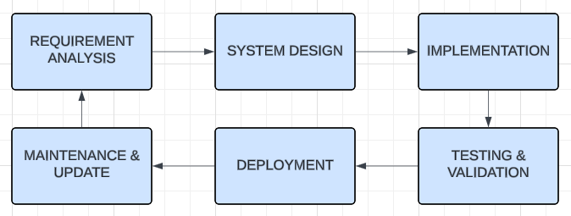
Figure 1:System Methodology Diagram

CHAPTER TWO

LITERATURE REVIEW

2.1 Introduction
This chapter provides a comprehensive review of existing literature relevant to the development of secure and accessible E-voting systems. It explores the foundational concepts, technologies, and scholarly works that support the design of electronic voting platforms with a particular focus on cybersecurity and accessibility. The review is structured to give insight into the evolution of E-voting, the current state of research in cybersecurity as it relates to voting systems, and how accessibility has been approached in previous implementations.
The chapter begins by providing an overview of E-voting systems, including their components and classifications. It then delves into cybersecurity considerations, identifying the critical threats, security mechanisms, and best practices used in securing electronic voting platforms. Following this, the chapter examines accessibility features that ensure E-voting systems are inclusive to all eligible voters, regardless of physical or cognitive abilities.
The literature review also evaluates existing E-voting systems from both global and local perspectives, discussing the technologies used, the strengths and weaknesses observed, and the lessons learned from their deployment. This provides a contextual foundation for identifying existing research gaps and justifying the need for a new system tailored to the requirements of the Independent Electoral and Boundaries Commission (IEBC) of Kenya.

2.2 Theoretical Review and Conceptual Framework
This section provides a review of relevant theoretical and empirical literature underpinning the development of secure and accessible E-voting systems. The analysis focuses on key constructs aligned with the research questions and objectives, particularly cybersecurity, system accessibility, and usability in E-voting environments. It highlights prior methodologies, identifies gaps, and establishes the conceptual relationships between variables for deeper analysis.

2.2.1 Cybersecurity in E-Voting Systems
Cybersecurity is foundational in ensuring trust, transparency, and confidentiality in E-voting systems. Research has shown that election infrastructure is a prime target for cyber threats, ranging from denial-of-service attacks to malware and vote manipulation (Cordero & Cortier, 2019). Various approaches such as end-to-end encryption, voter authentication protocols, and secure audit trails have been adopted to address these concerns (Cranor & Garfinkel, 2005; Eubank et al., 2020).
The theoretical underpinning draws from information security frameworks like the CIA Triad (Confidentiality, Integrity, and Availability), which guide how E-voting systems manage and mitigate risks. For instance, confidentiality ensures ballot secrecy, integrity ensures votes are accurately recorded and counted, and availability ensures the system is accessible throughout the election period.
Methodologies used in past research range from experimental deployment to simulation modeling and cryptographic audits. However, many of these systems face limitations in scalability or resistance to emerging cyber threats.
In Kenya, the 2017 general election faced a series of allegations about unauthorized access to the IEBC’s Results Transmission System (RTS), raising doubts about electoral data integrity and transparency (Daily Nation, 2017). While a formal breach was not confirmed, the incident highlighted systemic weaknesses in electoral cybersecurity infrastructure.
Internationally, countries like Estonia have deployed robust e-voting systems utilizing end-to-end encryption, blockchain verification, and secure ID logins, offering a global benchmark for digital election security (Vassil et al., 2016).

2.2.2 Accessibility in E-Voting Systems
Accessibility refers to the extent to which all eligible voters, including individuals with disabilities, the elderly, and rural populations, can effectively use an E-voting system. Studies have emphasized the importance of inclusive design, which accommodates screen readers, multilingual support, and mobile responsiveness (Bryans & Littlewood, 2015; Smith et al., 2017).
Universal usability and the Web Content Accessibility Guidelines (WCAG) provide theoretical support for accessible system design. These frameworks have been applied in designing government systems in Estonia, India, and Canada, but there remains a gap in consistent global implementation especially within African electoral contexts.
In Kenya, accessibility remains a challenge, especially for voters in rural regions with limited internet access and among the visually impaired. A notable effort by IEBC in 2022 involved piloting voter registration kits that were compatible with braille and fingerprint identification, but their deployment was limited (IEBC, 2022).
Globally, Canada’s Elections Ontario developed accessible voting terminals with audio ballots and tactile keypads to assist visually impaired users. This model could be adapted for mobile-friendly or web-based platforms in African contexts.
Empirical studies have used user-centered design, surveys, and observational testing to assess accessibility. However, few systems combine both high-level security and accessibility in an integrated way. This leaves a gap for solutions tailored to regional infrastructure, such as that of the IEBC.

2.2.3 Usability and User Trust in E-Voting Systems
Trust and ease-of-use play critical roles in voter adoption of electronic systems. A system that is secure and accessible still needs to be intuitive and culturally acceptable to its users. Studies on human-computer interaction (HCI) have found that perceived ease-of-use and trustworthiness increase participation (Fuglerud & Tjøstheim, 2014; Gibson et al., 2016).
The Technology Acceptance Model (TAM) provides a theoretical foundation for assessing how users perceive and engage with voting technology. Factors like perceived usefulness, system reliability, and transparency directly influence voter behavior.
In the Kenyan context, a KICTANet (Kenya ICT Action Network) report from 2022 highlighted low voter trust in electronic systems due to poor communication by electoral agencies and lack of user training. This mistrust is compounded by political tensions, which can erode public faith in technology-based solutions, regardless of their technical competence (KICTANet, 2022).
Estonia’s success in fostering trust stems from years of civic education and incremental tech adoption, proving that usability must be paired with transparency and user awareness campaigns.
Methodologies used include usability testing, interviews, and behavioral modeling. However, existing research has often neglected the psychological aspects of voter behavior in high-risk political environments, which is vital in Kenya.

2.3 Conceptual Framework
The conceptual framework links the hypothesized variables: cybersecurity, accessibility, and usability, and demonstrates how each influences the adoption and effectiveness of a secure E-voting system. These variables are aligned with the research questions and guide both system design and evaluation.
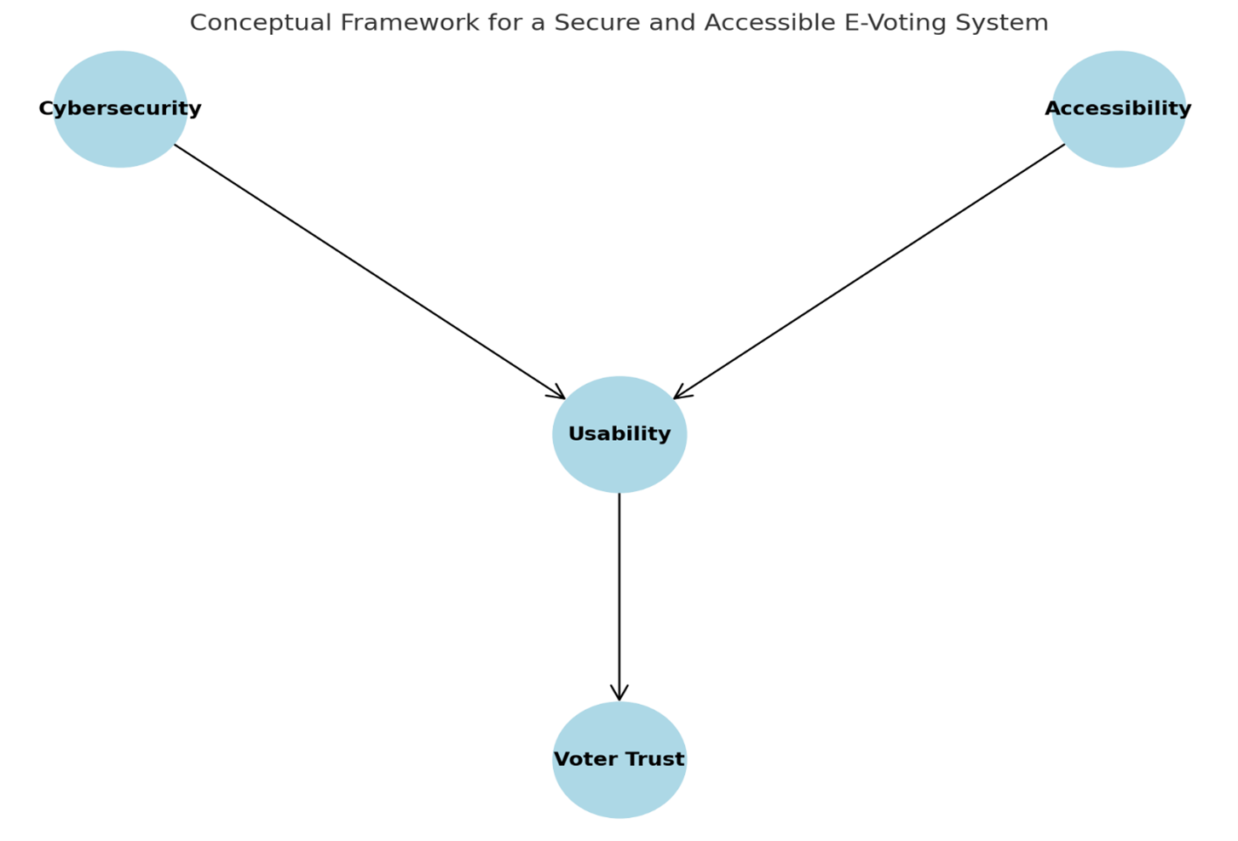
Figure 2:Conceptual Diagram
It shows how Cybersecurity and Accessibility influence Usability, which in turn builds Voter Trust a key objective of your system.

2.4 Critique of Existing Literature
Several studies have addressed the development and implementation of electronic voting (E-voting) systems across different global and regional contexts. While the existing body of literature provides a valuable foundation, it also reveals critical limitations, especially concerning cybersecurity, accessibility, and voter trust core aspects of the current study.
Cybersecurity in E-voting Systems
Most scholarly work acknowledges that cybersecurity is the cornerstone of any electronic voting system. Studies such as those by Adida (2008) and Springall et al. (2014) have detailed how vulnerabilities in online voting platforms can compromise election integrity. For instance, the Helios voting system, although verifiable, was found to have loopholes susceptible to external tampering and internal misconfiguration (Adida, 2008). These findings demonstrate a recognition of the threat landscape but often fail to propose holistic cybersecurity frameworks tailored for public elections.
Locally, Kenya’s IEBC has been criticized over cybersecurity preparedness, especially following the 2017 general elections when concerns were raised about unauthorized access and data breaches (Odhiambo et al., 2021). These incidents underscore the need for more secure, transparent, and auditable systems, especially within African electoral frameworks.
The IEBC’s preparedness has repeatedly come under scrutiny, particularly after the alleged hacking of election servers in 2017. A Supreme Court ruling nullified the presidential election partly due to irregularities in electronic transmission (Supreme Court of Kenya, 2017).
This real-world case illustrates the need for cryptographic audits and independent cybersecurity oversight.
Accessibility and Inclusivity in E-voting
Literature focusing on accessibility especially for persons with disabilities or those in remote areas remains sparse. Although E-voting is often touted for its potential to improve voter participation (Kumar et al., 2018), few systems have effectively integrated adaptive interfaces or low-bandwidth designs. Moreover, existing research largely omits multilingual support and mobile responsiveness, crucial features in diverse countries like Kenya.
Despite legislative frameworks like the Persons with Disabilities Act (2003), most Kenyan electoral systems have failed to incorporate assistive technologies in polling or digital platforms. The lack of multilingual interfaces and rural network optimization remains a major barrier.
User Trust and System Usability
Trust is a recurrent theme in most discussions on E-voting. According to Gibson et al. (2016), voter confidence is directly influenced by their perceived control over the process, transparency of the system, and the ease of interaction with the platform. Yet, studies often focus more on technological capability than the user experience, resulting in systems that are technically sound but poorly adopted.
For example, in Estonia a global leader in E-voting the system’s security and ease of use have contributed significantly to public trust (Vassil et al., 2016). However, attempts to transplant similar systems into less digitally developed nations have not been as successful due to contextual differences in infrastructure and civic education.
A 2022 observation by Afrobarometer revealed that over 60% of young Kenyan voters were skeptical about electronic transmission of results, citing lack of transparency and poor digital education as reasons for low adoption.

2.5 Summary
This chapter critically reviewed the theoretical and empirical foundations surrounding the development of secure E-voting systems, particularly in the context of cybersecurity and accessibility. Theoretical models such as the Technology Acceptance Model (TAM), Information Systems Success Model, and the CIA Triad (Confidentiality, Integrity, and Availability) formed the basis for understanding how security and usability influence user acceptance of technology-based voting systems.
The conceptual framework developed illustrates the relationship between core variables cybersecurity, accessibility, usability, trust, and system efficiency showing how these interact to impact the overall effectiveness of an E-voting platform. This framework offers a structured lens through which the proposed system will be analyzed and developed.
A review of related empirical literature revealed a global trend toward digital transformation in elections, with notable implementations in Estonia and Switzerland. However, these systems often face challenges related to trust, digital divide, and implementation in low-resource settings. Locally, Kenya’s Independent Electoral and Boundaries Commission (IEBC) has made efforts toward adopting technology, but issues around voter identification, transmission of results, and public confidence remain prevalent.
The critique of existing literature identified several gaps, notably the limited integration of robust cybersecurity frameworks with inclusive, accessible design especially in the African context. Moreover, many past studies emphasized system features while overlooking user-centered design, trust-building measures, and implementation feasibility in diverse environments.
While global leaders like Estonia and Canada have made significant strides in building inclusive and secure E-voting systems, Kenya’s unique challenges such as limited infrastructure, varying digital literacy, and electoral skepticism necessitate localized solutions. Lessons from previous IEBC attempts and citizen feedback should guide the development of robust, citizen-centered platforms.

2.6 Research Gaps
Despite the growing body of literature on electronic voting systems globally, several notable gaps remain particularly in the integration of cybersecurity, accessibility, and contextual adaptability in emerging democracies such as Kenya. The following research gaps have been identified:
- Limited Focus on Accessibility for Diverse Voter Groups
Many E-voting studies and systems fail to adequately address the needs of users with disabilities, limited digital literacy, or those in rural areas with constrained internet access. While accessibility is recognized in theory, few practical implementations exist that cater to this diversity, especially within the African context (Ali et al., 2021; Mitrou et al., 2022).
- Inadequate Integration of Cybersecurity Frameworks in User-Centered Design
Existing systems tend to prioritize either security or usability rarely both. Literature shows a lack of comprehensive models that combine strong cybersecurity protocols with intuitive, user-friendly interfaces suitable for real-world deployment (Abdelghaffar & Magdy, 2020; Islam et al., 2021).
- Scarcity of Empirical Studies on Voter Trust and System Adoption
While theoretical models like the TAM suggest that trust and perceived ease-of-use influence technology adoption, there is limited empirical research measuring voter attitudes toward E-voting systems in Kenya and similar socio-political environments (Kumar & Bansal, 2021; Karayil & Kavitha, 2020).
- Insufficient Real-World Prototypes or Pilot Studies
Much of the existing literature remains conceptual or simulation-based. There is a need for practical, web-based prototypes tested in real-world conditions to validate theories and demonstrate feasibility in actual election environments (Estonian National Electoral Committee, 2022; Oyelami et al., 2019).

CHAPTER 3:

SYSTEM ANALYSIS AND DESIGN

3.1 Introduction
This chapter builds upon the foundation laid in the previous chapters, where the need for a secure and accessible E-voting system was identified and analyzed. With a clear understanding of the research gaps, user needs, and the challenges in the current electoral processes, this chapter translates the theoretical concepts into a practical system design and implementation strategy.
The primary goal of this chapter is to outline the system's technical architecture and design methodology. It details the functional and non-functional requirements, proposed system modules, security mechanisms, and accessibility considerations all aligned with the objectives of the study and the operational needs of the Independent Electoral and Boundaries Commission (IEBC). The use of the Waterfall development methodology is also explained, showing a structured progression from requirements gathering to implementation and testing.
Specifically, this chapter covers:
- A clear articulation of both functional and non-functional system requirements;
- A detailed system design including architecture diagrams, data flow, and entity relationships.
- The technology stack used for development and justification for its choice;
- A comprehensive cybersecurity strategy to ensure confidentiality, integrity, and availability of electoral data;
- Provisions for accessibility to accommodate diverse voter needs;
- Modular breakdown of the system’s core components;
- And the testing plan to ensure reliability and usability.
Through this analysis and design, the system aims to offer a secure, user-friendly, and transparent web-based voting platform that can enhance voter trust and participation in Kenya's democratic processes.

3.2 System Development Methodology
System development methodologies provide a structured framework for planning, designing, developing, testing, and deploying software systems. Choosing the right methodology is critical in ensuring that the final product meets user needs, maintains high quality, and is delivered within the project constraints of time and resources.
For this secure E-voting system project, the Waterfall Development Methodology was selected. This methodology follows a linear and sequential approach where each phase must be completed before the next begins. The waterfall model is particularly suitable for this project due to its clarity, ease of management, and its alignment with the project’s defined scope, timeline (8 months), and strict requirements especially in the context of cybersecurity and electoral integrity.
The distinct phases of the waterfall model applied in this project are as follows:
- Requirements Analysis – Collection and documentation of system requirements based on user needs and problem definition from Chapter 1.
- System Design – Translating requirements into architectural blueprints, including data flow, system architecture, and module design.
- Implementation – Actual coding of the system based on the designed specifications using selected web technologies.
- Testing – Conducting various levels of testing including unit, integration, system, and user acceptance testing to ensure correctness and security.
- Deployment – Launching the system for demonstration or real-world pilot use by the IEBC.
- Maintenance (Post-Project Recommendation) – Suggestions for future maintenance and scalability.
The structured nature of the waterfall methodology provides a disciplined approach which is ideal for mission-critical systems like E-voting, where each step must be carefully verified before proceeding. Its documentation-driven nature also ensures traceability and accountability, aligning with the transparency requirements of electoral systems.

3.3 Feasibility Study
A feasibility study is a critical phase in system development that assesses whether a proposed system is viable, practical, and worthwhile before substantial resources are committed. It helps determine if the system can be successfully developed and implemented considering various dimensions such as technology, cost, and user adoption.
For the proposed Secure E-voting System, the feasibility study focuses on three primary aspects:
- Technical Feasibility
- Economic Feasibility
- Operational Feasibility
These three dimensions are essential to ensure that the system not only works but also fits within the available technological environment, budget constraints, and organizational structure.

3.3.1 Technical Feasibility
Technical feasibility evaluates whether the current technological infrastructure, skills, and tools are sufficient to support the development and deployment of the proposed system.
For this E-voting project, the technical feasibility is strongly positive based on the following factors:
- Availability of development tools: The system has been developed as a web application using widely available and well-supported technologies such as HTML, CSS, JavaScript (React or Vue), PHP/Python, and MySQL or PostgreSQL databases. These tools are open-source and compatible with many hosting environments.
- Cybersecurity implementation: Security protocols such as SSL encryption, firewall protection, and secure session management will be integrated to uphold the system’s integrity, confidentiality, and availability. These technologies are not only available but are also industry-standard and well-documented.
- Internet and hosting infrastructure: The system is designed for deployment on secure cloud-based or local server infrastructure with reliable uptime, allowing for accessibility and scalability during election periods.
- Human resource capability: The development team has adequate knowledge in cybersecurity, full-stack web development, and system integration making it possible to develop, test, and deploy the system within the 8-month window.
- Scalability: The proposed design allows for modular growth, meaning the system can be scaled up to accommodate national election requirements or down for regional or institutional use.

3.3.2 Economic Feasibility
Economic feasibility assesses whether the benefits of the proposed system justify the projected costs of development and operation. It helps decision-makers determine if the investment is worthwhile by analyzing the cost-benefit ratio of the project.
In this Secure E-voting System, this study helps ensure that the IEBC or any adopting institution can afford to develop, implement, and maintain the system without excessive financial strain.
Key Considerations:
- Development costs (software, tools, personnel)
- Operational costs (hosting, maintenance, updates)
- Benefits (reduced manual labor, fraud prevention, time-saving, transparency)
Estimated Cost Breakdown
Table 1:Economical Feasibility Breakdown
Category | Description | Estimated Cost (KES)
Personnel | My Personal Computer (Already exist) | 0
Internet & Hosting Services | Domain, SSL, Cloud Hosting for 8 months | 15,000
Software Tools | IDEs, Libraries, Frameworks (mostly open-source) | 0
Cybersecurity Services | Firewall setup | 5,000
Hardware (if applicable) | Mouse, UPS (already available, hence not counted) | 0
Miscellaneous | Contingency, communication, stationery | 5,000
Total Estimated Cost |  | KES 25,000

Benefit Analysis (Qualitative + Quantitative)
Table 2:Expected Benefits of Economic Feasibility
Expected Benefits | Remarks
Reduced manual voting costs | No need for large ballot printing or transport
Transparency & fraud reduction | Saves millions by preventing rigging and repeat elections
Faster result tallying | Speeds up declaration of results, saving logistical costs
Long-term scalability | System usable across multiple future elections

3.3.3 Operational Feasibility
Operational feasibility assesses whether the proposed system can be successfully integrated and operated within the existing processes, culture, infrastructure, and workflows of the intended users or organization. It answers the question: "Will the system actually work in practice?"
Key Considerations:
- User adoption and ease of use
- Compatibility with existing election practices
- Training and support requirements
- Institutional readiness (e.g., IEBC, polling officers)
- Cultural and political acceptance
Assessment of Operational Feasibility for the Secure E-Voting System
The operational feasibility of the Secure E-Voting System has been evaluated across several key factors to determine its practicality and adaptability in a real-world electoral environment, particularly under the mandate of the Independent Electoral and Boundaries Commission (IEBC).
To begin with, user-friendliness is a primary design consideration. The system features a clean, intuitive web interface that ensures ease of use for voters across varying levels of digital literacy. This design approach makes it accessible not only to tech-savvy individuals but also to first-time users, including the elderly and those with minimal interaction with digital systems.
Regarding training requirements, the system is streamlined to minimize the need for extensive training. While voters can comfortably interact with the platform without specialized guidance, polling officials and administrative staff may require brief training sessions. These sessions would mainly focus on backend system management, monitoring, and reporting functionalities.
In terms of language and inclusivity, the system has been developed with support for multiple local languages, enhancing accessibility for Kenya’s linguistically diverse population. Additionally, features such as text-to-speech functionalities are being explored to accommodate visually impaired users, thus promoting inclusivity and aligning with accessibility standards.
The availability of infrastructure has also been factored into the system’s design. The platform assumes basic access to internet-enabled devices such as smartphones or computers, which are increasingly common in both urban and rural Kenyan communities. However, recognizing potential disparities in connectivity, provisions for offline fallback mechanisms are considered for future enhancements.
When assessing compatibility with the existing election workflow, the system aligns closely with IEBC’s operational procedures. It integrates seamlessly with current voter registration, identification, and verification frameworks, ensuring that it complements rather than disrupts the broader election process.
From a security and trust standpoint, the platform adopts a cybersecurity-first approach. Measures such as two-factor authentication (2FA), end-to-end encryption, and secure audit logs are embedded into the architecture to guarantee the integrity and confidentiality of the voting process. These features are crucial in cultivating trust among stakeholders, especially in light of past concerns surrounding election integrity.
Finally, support and maintenance requirements are modest. Once deployed, the system is expected to operate with minimal ongoing technical intervention. Routine support could be handled by the existing ICT department within IEBC or outsourced to a third-party service provider, ensuring sustainability and scalability for future electoral cycles.
Stakeholder Acceptance
A critical element of operational feasibility is stakeholder buy-in, particularly from:
- IEBC (the system’s primary operator)
- Political parties and candidates
- Voters and civil society

3.4 Requirement Elicitation
Requirement elicitation is the process of collecting, discovering, and understanding the functional and non-functional requirements of a system from stakeholders. For the Secure E-voting System targeting the IEBC and voters in Kenya, we utilized a combination of data collection tools to ensure a comprehensive understanding of user needs and system expectations.

3.4 Data and System Analysis
Data and system analysis involves the systematic examination of gathered requirements, user feedback, and current electoral processes to identify key functionalities, user expectations, and potential system limitations. This analysis ensures that the final solution aligns with real user needs while enhancing security, accessibility, and efficiency for the Independent Electoral and Boundaries Commission (IEBC).

3.4.1 Data Analysis
After administering questionnaires, conducting interviews, and performing observations, the collected data was analyzed both quantitatively and qualitatively.
Questionnaire Data Analysis
- Data from closed-ended questions was analyzed using basic statistical tools such as frequencies and percentages.
- For example:
  - 75% of respondents preferred an online voting system for convenience.
  - 82% were concerned about the security of digital voting.
  - 68% had access to mobile devices with internet connectivity.
These results show strong user interest in a digital voting platform but also emphasize the importance of cybersecurity and accessibility in the system’s design.
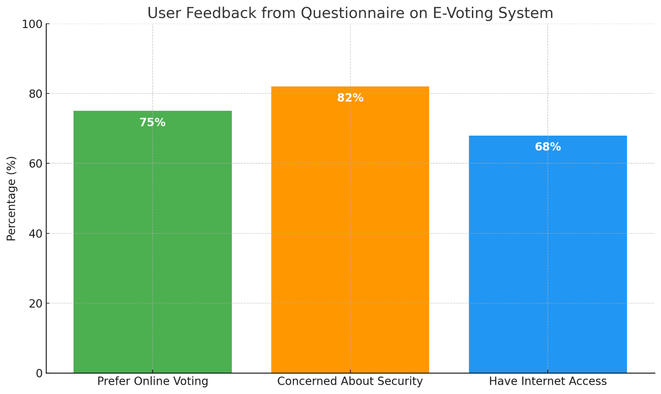
Figure 3: User Feedback from Questionnaire

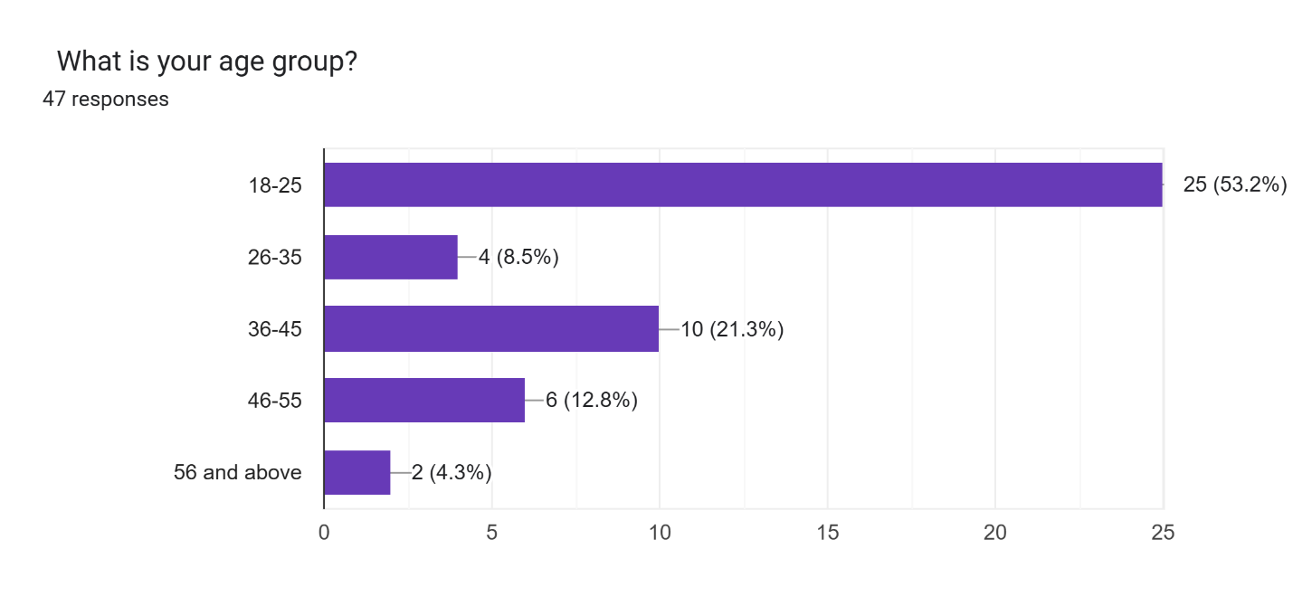
Figure 4: Age Group Response

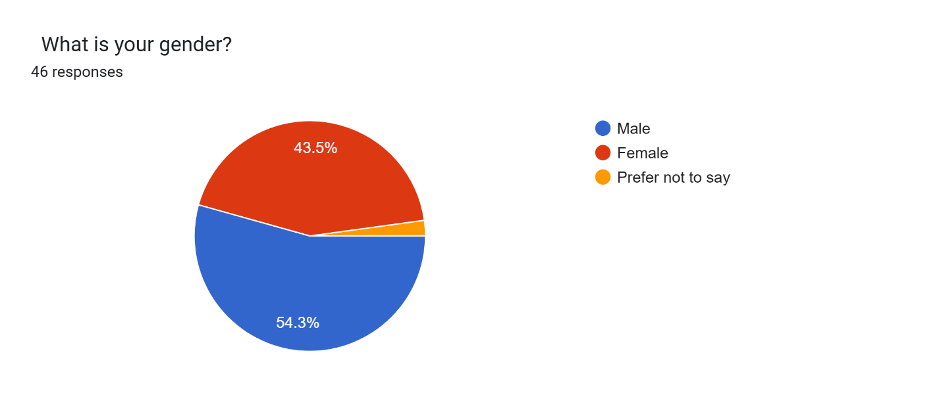
Figure 5: Gender Response

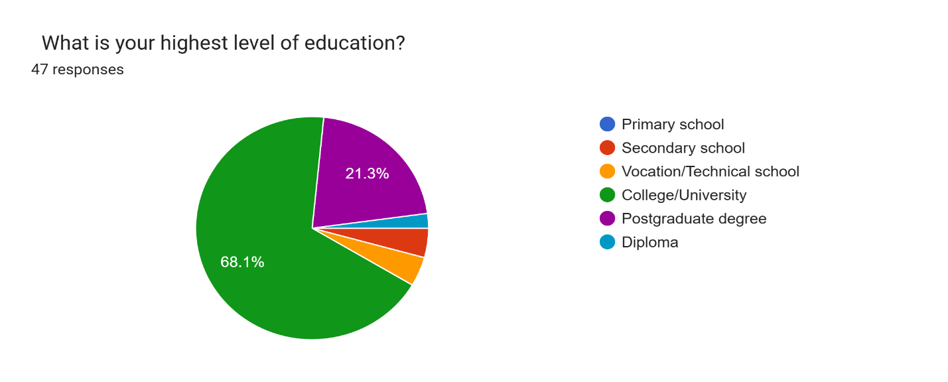
Figure 6: Level of Education Response

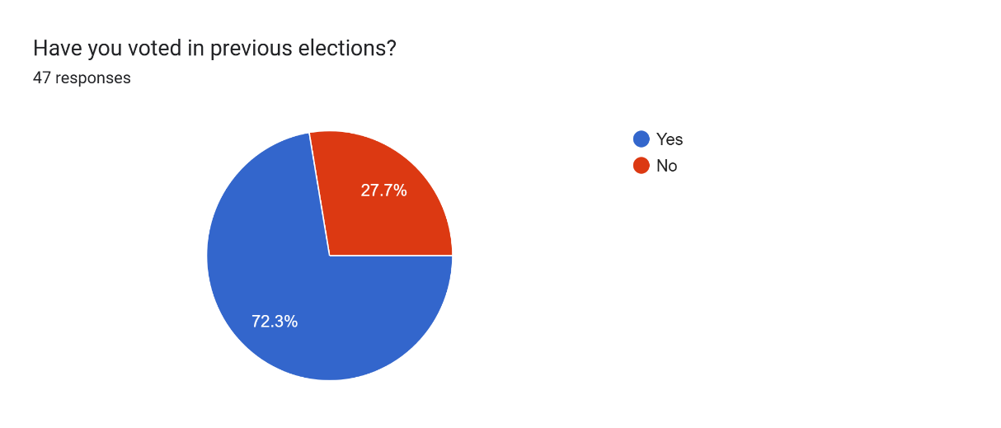
Figure 7: People who voted in the previous Election

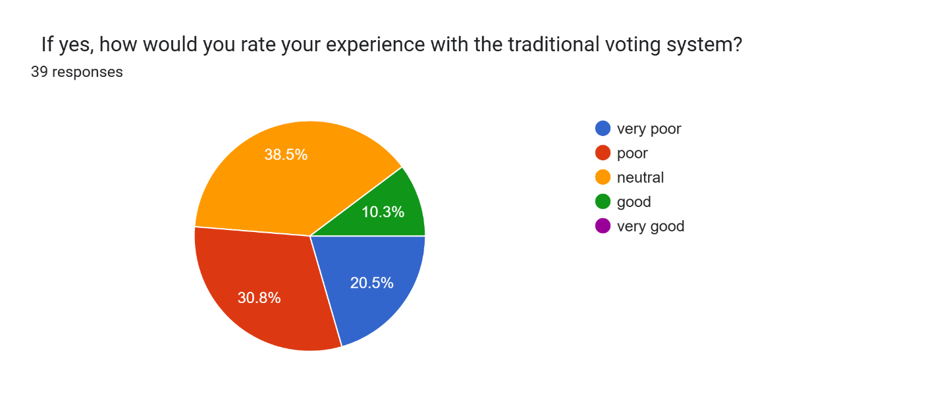
Figure 8: Ratio experience of the Tradition Voting System
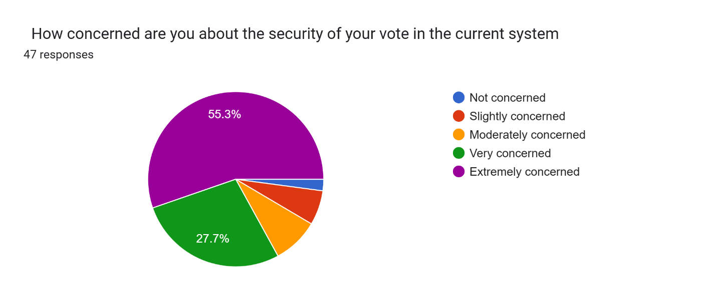
Figure 9: Concern of Security of the Current System

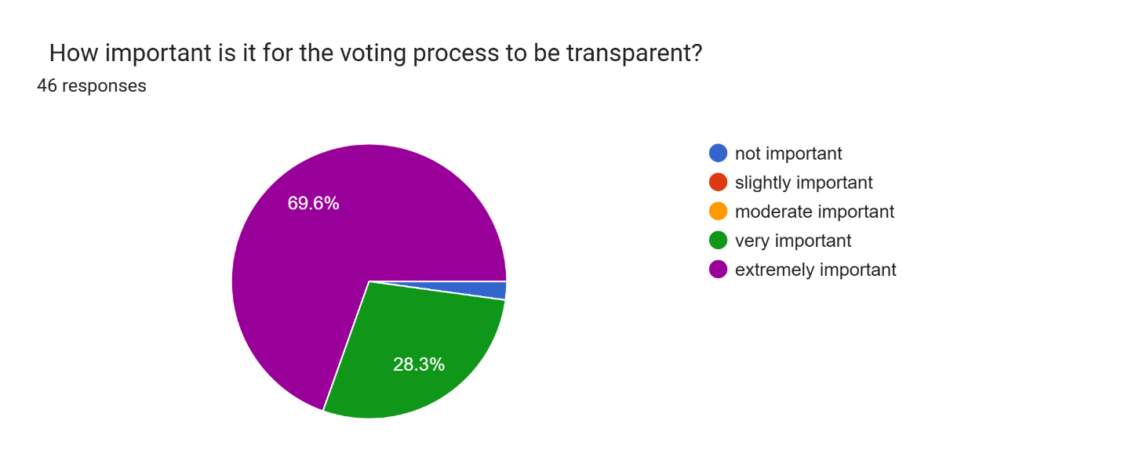
Figure 10: Importance of Transparency

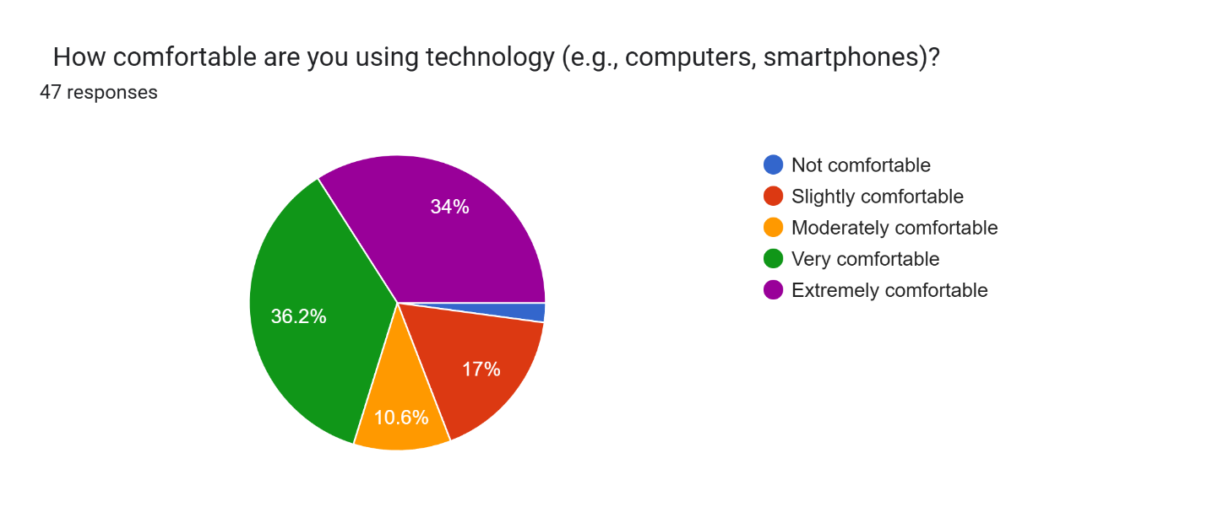
Figure 11: Comfortability of using Technology

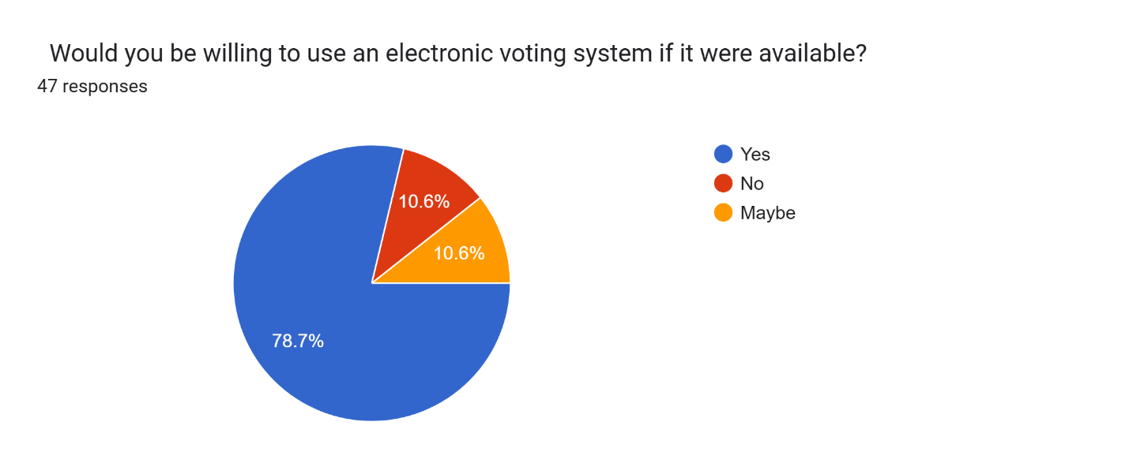
Figure 12: Willingness of using Electronic-Voting System

Interview and Observation Analysis
- Common concerns raised during interviews included:
  - System hacking or manipulation
  - Voter impersonation
  - Connectivity issues in rural areas
- Suggestions included:
  - Multi-factor authentication
  - Offline backup systems
  - Simple, multilingual interfaces
These insights helped shape the functional and non-functional requirements of the system, particularly in terms of security features, redundancy, and user experience.

3.4.2 System Analysis
System analysis focuses on understanding and modeling the current and proposed systems to identify how best to transition into the secure E-voting system.
Existing System Overview (Manual/Traditional Voting)
- Paper-based system with physical verification and manual counting
- High risk of human error and manipulation
- Time-consuming tallying process
- Limited accessibility for people with disabilities and diaspora voters
Identified Weaknesses in the Current System
- Prone to ballot stuffing, rigging, and vote miscounting
- Voter intimidation in some regions
- Logistical challenges (e.g., ballot transportation and security)
- Delays in result transmission
Proposed System Improvements
- Secure login with password-based authentication
- Real-time voting and result transmission
- User-friendly interfaces for voters and IEBC officials
- Cybersecurity implementation including encryption and firewall protocols
- Role-based access for administrators, officials, and voters

3.5 System Specification
The system specification outlines the requirements necessary for the development and implementation of the secure E-voting system for the Independent Electoral and Boundaries Commission (IEBC). These requirements are derived from stakeholder expectations, collected data, and the nature of a secure, accessible web-based voting platform.
1. Functional Requirements
These are the core functions the system must perform to meet user and stakeholder needs.
- User Registration and Authentication
  - The system shall allow eligible voters to register securely.
  - It shall authenticate users using secure credentials (e.g., voter ID, OTP, biometric verification).
- Ballot Casting
  - The system shall allow authenticated voters to view their correct ballot and cast votes electronically.
  - It shall provide a confirmation page before vote submission.
- Vote Encryption
  - The system shall encrypt all vote data to ensure confidentiality and integrity.
- Vote Counting and Result Tallying
  - The system shall automatically tally votes securely and in real-time.
- Admin Dashboard
  - Election officials shall be able to manage the election setup, monitor participation, and view reports.
- Audit and Logging
  - The system shall maintain a secure and tamper-proof log of all transactions for auditing purposes.
- Voter Receipt
  - The system shall provide an optional anonymous receipt confirming the vote was submitted.
2. Non-Functional Requirements
These define the quality attributes the system must possess to perform reliably and securely.
- Security
  - The system shall implement cybersecurity best practices such as encryption, intrusion detection, firewalls, and secure user sessions.
  - All data shall be protected using AES-256 encryption standards.
- Accessibility
  - The system shall be accessible on various devices (PCs, tablets, smartphones) and comply with WCAG 2.1 accessibility standards.
  - It shall include multilingual support and options for users with disabilities.
- Scalability
  - The system shall be capable of handling millions of users concurrently during peak voting hours.
- Performance
  - The system shall load all pages within 2 seconds and process vote submissions in real-time.
- Availability
  - The system shall maintain 99.9% uptime during the election period.
- Maintainability
  - The codebase shall be modular and well-documented to allow easy updates and troubleshooting.
- Usability
  - The interface shall be user-friendly, with a simple and intuitive voting process.

3.6 Logical Design
The Logical Design of the secure E-voting system defines how the system components interact to achieve its functionality without focusing on the physical implementation. It focuses on the structure of data, process flows, and relationships between different system entities from a conceptual level.
Logical design includes:
- Entity relationships between users (voters, admins), candidates, voting events, and ballots.
- Process flow diagrams that show the journey of a voter from registration to casting a vote.
- Validation rules for voter authentication, voting deadlines, and secure access control.
- User roles and permissions, ensuring that only authorized users can access sensitive functions (e.g., result viewing or admin controls).
- Data abstraction, where sensitive information like passwords or vote data is handled securely without showing implementation logic.
This stage forms the foundation for the physical design by clearly outlining what the system should do, how data flows, and how users interact with the platform.

3.6.1 System Architecture (System Tiers and Components)
To ensure robustness, scalability, and maintainability, the secure E-voting system is designed using a Three-Tier Architecture. This architectural model separates the system into three independent layers:
1. Presentation Tier (Client Layer)
- Description: This is the user interface where voters, administrators, and other stakeholders interact with the system.
- Technologies: HTML, CSS, JavaScript, Bootstrap, or modern frontend frameworks (like React or Angular).
- Features:
  - User-friendly web interface for ease of voting.
  - Responsive design for accessibility on mobile and desktop.
  - Secure login pages, forms for registration and voting.
2. Application Tier (Logic/Business Layer)
- Description: This layer contains the business logic of the application. It handles processes such as user authentication, vote processing, encryption, validation, and result computation.
- Technologies: Backend frameworks like Node.js, Django, Laravel, or Spring Boot.
- Features:
  - Secure APIs to handle vote submissions and authentication.
  - Vote encryption before storage or transmission.
  - Session management, input validation, and error handling.
  - Access control for different system roles.
3. Data Tier (Database Layer)
- Description: The data layer stores all persistent information such as user data, encrypted votes, logs, and election results.
- Technologies: SQLite.
- Features:
  - Encrypted storage of votes and sensitive information.
  - Backup and recovery mechanisms.
  - Logs of all transactions for audit and traceability.
  - Read/write access controlled strictly via application layer.
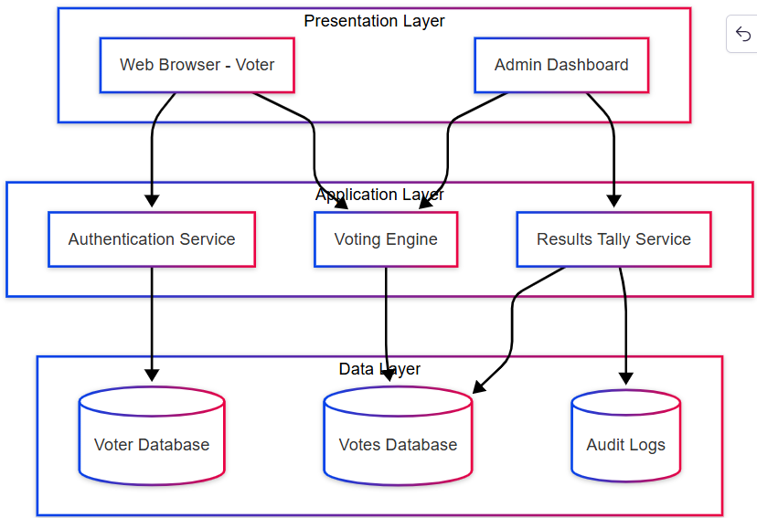
Figure 13:System Architecture Diagram

3.6.2 Class Diagram (Data Organization and Relationships)
A class diagram is one of the fundamental diagrams in object-oriented system design. It provides a blueprint of the system's structure by showing the system’s classes, their attributes, methods (behaviors), and the relationships among objects.
Key Components in the Class Diagram
- Class: Represents an entity with attributes (data) and operations (functions or methods).
- Attributes: Define the properties or data stored within each class.
- Methods: Functions that define the behavior of the class.
- Relationships:
  - Association: A relationship between two classes.
  - Aggregation/Composition: A whole-part relationship.
  - Inheritance: Represents a hierarchy between a superclass and subclasses.
Relationships Between Classes
- A Voter can cast one Vote (One-to-One).
- A Candidate can receive many Votes (One-to-Many).
- An Admin manages multiple Elections (One-to-Many).
- An Election includes multiple Candidates (One-to-Many).
- Every vote is logged in AuditLog for transparency (One-to-One or One-to-Many depending on granularity).
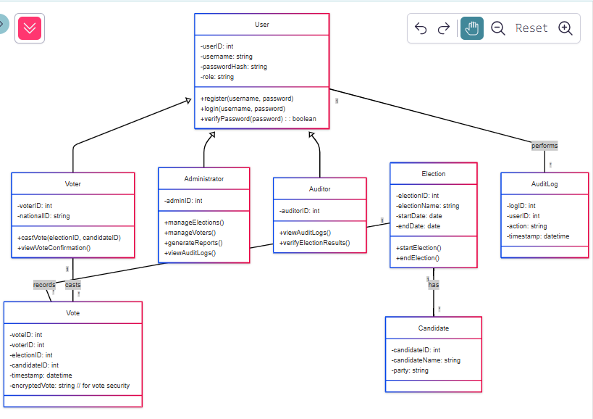
Figure 14:Class Diagram

3.6.3 Data Flow Diagrams (Information Flow in the System)
A Data Flow Diagram (DFD) is a graphical representation of the flow of data within a system. It shows how data enters the system, how it moves through different processes, and how it is stored or output. DFDs do not include control flow or decision rules but focus purely on the movement and transformation of data.
In a secure E-voting system, DFDs help visualize how voters interact with the system, how data like votes, results, and voter credentials are processed, and how security and integrity are maintained throughout the process.
DFD Levels
1. Level 0 DFD (Context Diagram)
This shows the system as a single process with its interaction with external entities.
Entities:
- Voter
- Administrator
- IEBC
Main Process:
- Secure E-Voting System
Data Flows:
- Login Details
- Vote Data
- Election Results
- Candidate Information
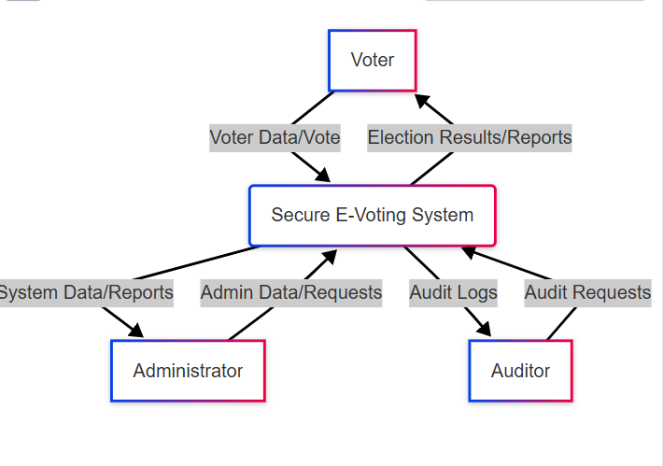
Figure 15:DFD Level 0

2. Level 1 DFD
This expands the main system process into sub-processes to show more detail:
Main Processes Might Include:
- User Authentication
- Vote Casting
- Vote Storage and Tallying
- Results Display
- System Monitoring and Audit Logging
Data Stores:
- Voter Database
- Candidate Records
- Vote Database
- Audit Logs
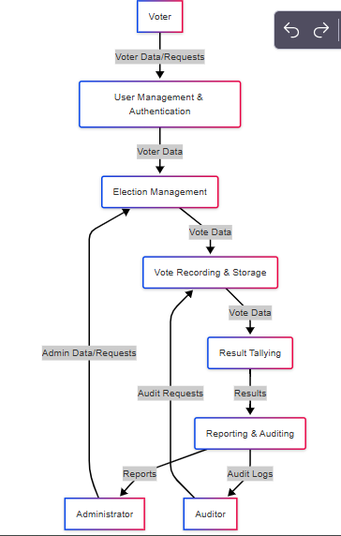
Figure 16:DFD Level 1

Control Flow and Process design

3.6.4 Use Case Diagram
A Use Case Diagram is part of the Unified Modeling Language (UML) that models the functional requirements of a system. It visually represents the interactions between users (actors) and the system in terms of use cases (actions or services).
In Secure E-Voting System, the use case diagram helps identify what the system should do, who interacts with it, and how the users engage with the core functionalities.
Actors in E-Voting System
- Voter
  - Registers and logs in
  - Views candidate list
  - Casts vote
  - Logs out
- Administrator
  - Manages users and candidates
  - Starts and ends voting sessions
  - Monitors voting process
- IEBC Official
  - Oversees system integrity
  - Accesses audit reports
  - Publishes official results
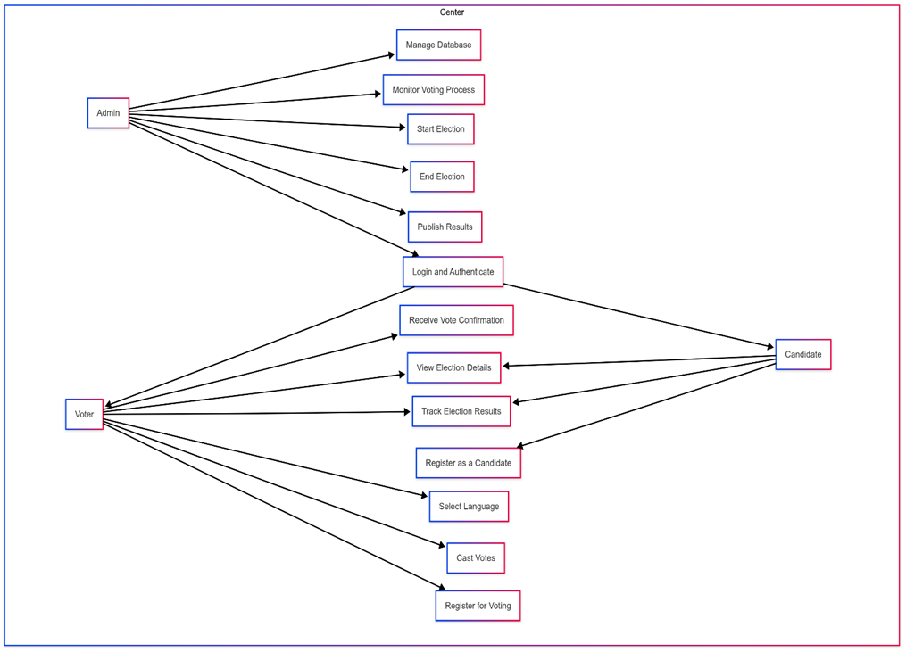
Figure 17:Use-case Diagram

Database design
A well-structured database is essential for ensuring data integrity, security, and efficient retrieval in the secure voting system. The database is designed to store voter information, election details, vote records, candidate data, and system logs.

3.6.5 Entity-Relationship Diagram (ERD)
An ERD (Entity-Relationship Diagram) is used to model the data entities and their relationships within the system.
Key Entities and Their Relationships
- Voter (Entity)
  - Attributes: VoterID, FullName, NationalID, Email, PhoneNumber, HasVoted (Yes/No)
  - Relationship: A Voter can cast one vote.
- Candidate (Entity)
  - Attributes: CandidateID, FullName, Party, Position
  - Relationship: A Candidate can receive multiple votes.
- Vote (Entity)
  - Attributes: VoteID, VoterID (FK), CandidateID (FK), Timestamp
  - Relationship: A Vote is linked to one Voter and one Candidate.
- Election (Entity)
  - Attributes: ElectionID, ElectionType, StartDate, EndDate
  - Relationship: An Election has multiple Candidates and Votes.
- Admin (Entity)
  - Attributes: AdminID, FullName, Email, Role
  - Relationship: An Admin can manage elections and candidates.
- Audit Log (Entity)
  - Attributes: LogID, UserID, Action, Timestamp
  - Relationship: Tracks actions of Voters and Admins for security auditing.
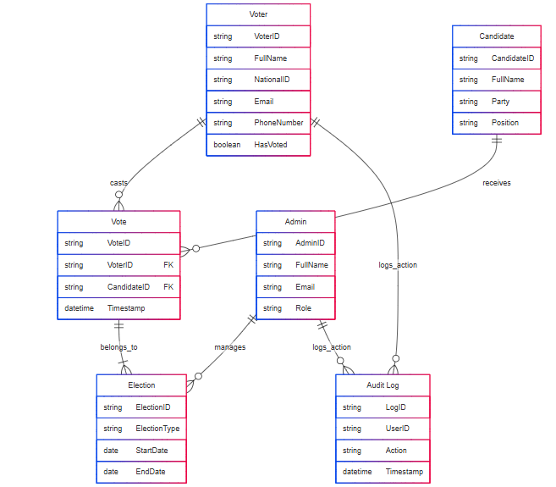
Figure 18:ER-Diagram

CHAPTER 4

SYSTEM IMPLEMENTATION AND TESTING

4.1 Introduction
This chapter presents the detailed implementation and testing of the Secure E-Voting System developed using the Django web framework. The system was designed to support transparent, secure, and accessible electronic voting processes. It covers the various components that were developed, including user management, role-based access, election creation, voting logic, results tallying, and audit logging.
The implementation process was carried out in a modular and incremental approach, using Django's MVT (Model-View-Template) architecture. The chapter outlines the tools and technologies used during development, discusses each core feature with supporting interfaces and logic, and concludes with system testing, project appraisal, and recommendations for future improvements.
Additionally, this chapter highlights the front-end integration and user interface polish to ensure the system is not only functionally sound but also user-friendly and accessible across devices.

4.2 Development Environment And Tools Used
The development of the Secure E-Voting System was carried out using the following tools and technologies:
Programming Language: Python 3.12
Python was selected for its simplicity, flexibility, and rich ecosystem of web development and security libraries.
Web Framework: Django 5.2
Django was used due to its built-in support for user authentication, admin interface, security features (like CSRF protection and ORM), and rapid development capabilities.
Database: SQLite
During development, SQLite was used as the backend database for ease of setup. The system can be configured to use PostgreSQL or MySQL for production deployments.
Frontend Technologies: HTML5, CSS3, Bootstrap 5, JavaScript
Bootstrap was used to ensure a responsive and accessible user interface. Custom styles were written in CSS and served through Django's static files system.
Development Tools:
- IDE: Visual Studio Code
- Virtual Environment: Python’s venv was used to isolate dependencies.
Libraries & Dependencies:
- cryptography: Used for encrypting vote data before storage.
- django-crispy-forms: For rendering Django forms with Bootstrap styling.
The combination of these tools ensured a secure, scalable, and maintainable development workflow.

4.3 System Architecture
The Secure E-Voting System is based on the Model-View-Template (MVT) architectural pattern provided by Django. This architecture enables a clear separation of concerns and promotes maintainability and scalability.
- Model: Defines the structure of the database tables. It includes models such as UserProfile, Election, Candidate, Vote, and AuditLog, which represent key entities in the system.
- View: Contains the logic for handling user requests and returning appropriate responses. Views are responsible for processing user input, querying the database, enforcing permissions, and rendering templates.
- Template: These are HTML files that define how the data from the views is displayed to users. Templates use Django's templating language and are styled using Bootstrap for responsiveness.
The system is organized into multiple modular Django apps, each responsible for a distinct functionality:
Table 4:Functionality
App Name | Description
users | Manages user registration, login, profile management, and roles
elections | Handles creation and management of elections and candidates
voting | Manages vote casting, vote encryption, and result display
audit | Logs critical system actions for audit and accountability
All these apps communicate via Django’s shared project settings and URL routing, with the admin site providing additional backend management. The architecture supports secure authentication, role-based access, encrypted vote storage, and real-time result computation.
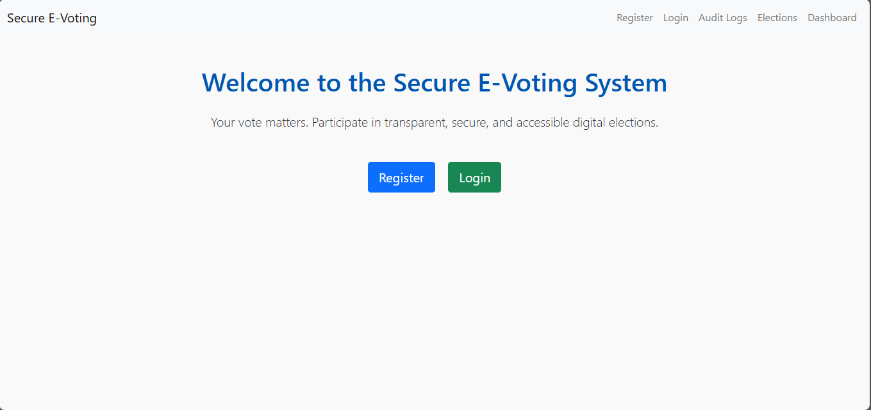
Figure 19:Homepage

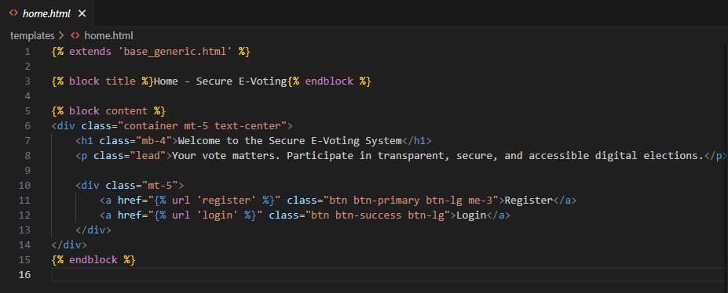
Figure 20:Homepage code

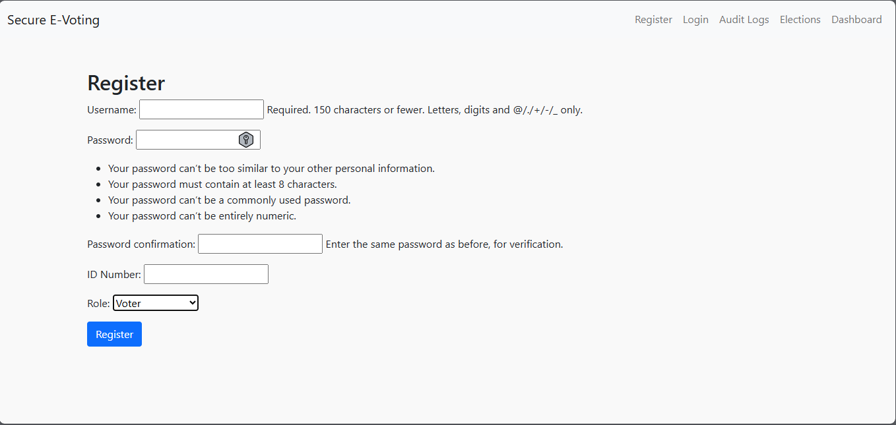
Figure 21:Registration page

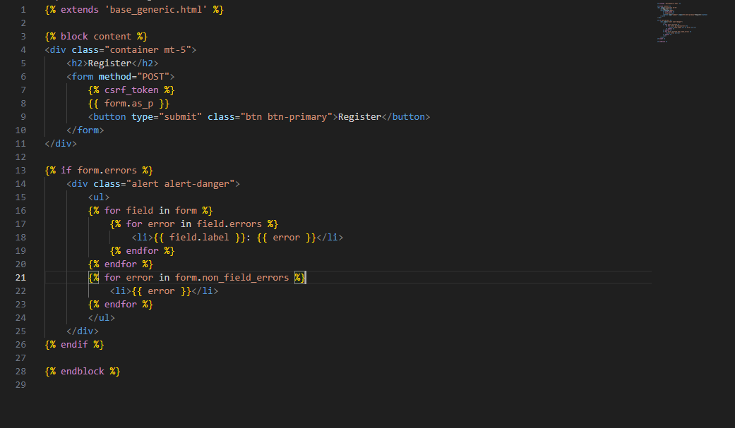
Figure 22:Registration code

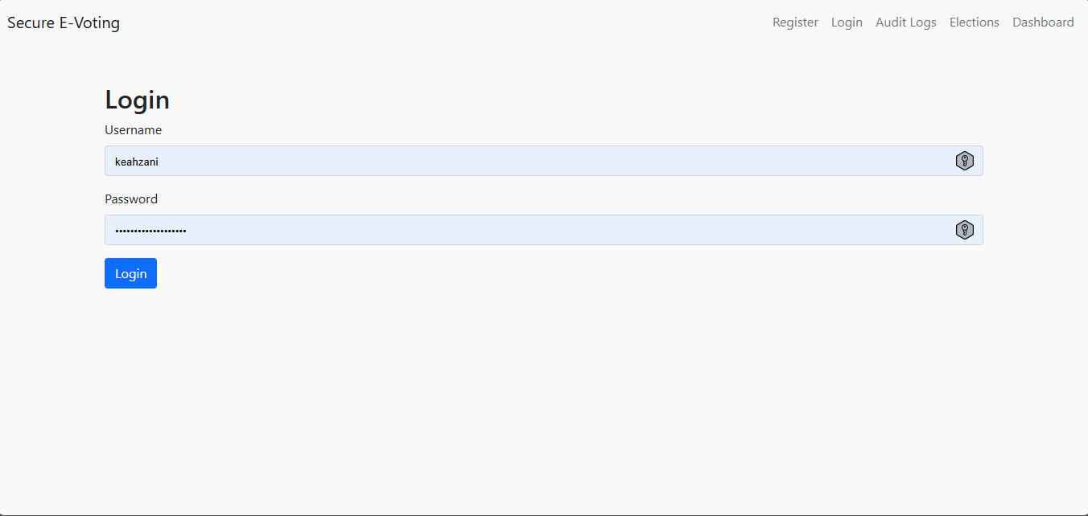
Figure 23:Login page

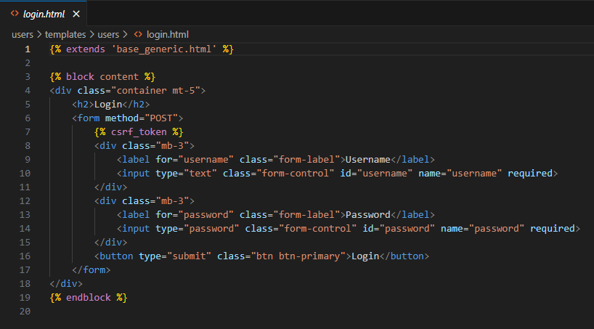
Figure 24:Login code

4.4 Testing
Testing was a critical part of the implementation process to ensure the Secure E-Voting System functioned as expected, was secure, and offered a user-friendly experience. Both manual and automated tests were conducted during development to verify the correctness of features, detect bugs, and ensure proper enforcement of voting restrictions and role-based access controls.
The tests were primarily carried out during active development using Django's built-in development server and admin tools. Functional validation was done for all user roles (admin, voter, election officer), and features were tested in isolation and end-to-end scenarios.

4.4.1 Types of Testing
The following types of testing were applied to the Secure E-Voting System:
- Unit Testing: Focused on individual components such as views, forms, and model methods. Django’s TestCase class was used to verify business logic and data handling at a micro level.
- Integration Testing: Ensured different modules (users, elections, voting, audit) worked correctly together. This was done manually by simulating complete workflows like registration → login → voting → result view.
- Functional Testing: Involved validating system functionalities from the user’s perspective. Each user role was tested for specific actions (e.g., voters casting a vote, admins creating elections).
- Security Testing: Special attention was given to protecting user data, vote encryption, authentication enforcement, CSRF protection, and ensuring voters could only vote once per election.
- UI/UX Testing: Ensured responsiveness, accessibility, and clarity of the user interface using various devices and screen sizes.

4.4.2 Test Cases and Reports
Several test cases were documented and executed during development. The table below summarizes key tests:
Table 5: Test Case and Reports
Test Case ID | Feature | Expected Result | Status
TC-01 | User registration | New user is created and redirected to login | Passed
TC-02 | Login authentication | Valid user logs in, invalid credentials are rejected | Passed
TC-03 | Role-based dashboard view | Voter sees eligible elections, Admin sees all tools | Passed
TC-04 | One-vote enforcement | Voter can only vote once per election | Passed
TC-05 | Vote encryption | Vote is stored encrypted in the database | Passed
TC-06 | Result tallying | Votes are correctly counted and displayed | Passed
TC-07 | Audit logging | Actions like voting, login, and creation are logged | Passed
TC-08 | Access control | Unauthorized users are redirected or blocked | Passed
TC-09 | UI responsiveness | Pages render correctly on different screen sizes | Passed
These test cases confirm that the system meets the functional and non-functional requirements.

4.5 Project Appraisal
The Secure E-Voting System project successfully achieved its core objectives, including secure vote casting, result tallying, and role-based access management. However, like any software system, it presents both strengths and areas with room for improvement. This section summarizes the main limitations and strengths observed during and after implementation.

4.5.1 Limitations
- No Voter ID Integration: The system does not currently integrate with a national ID or biometric system to verify voter identities beyond standard account credentials.
- Manual Election Result Publication: Although results are automatically tallied, publishing them is limited to a view-only page and is not integrated with external reporting systems.
- Vote Encryption Simplicity: While encryption was implemented, it uses a basic symmetric key model and lacks advanced features such as end-to-end voter verification or blockchain-level tamper resistance.
- No Email or SMS Notifications: The system does not notify users of election events or results through email or SMS.
- Limited Testing Coverage: Most testing was manual and functional. The system lacks automated test coverage, continuous integration, and stress testing under high user loads.

4.5.2 Strengths
- Secure Voting Workflow: Votes are encrypted before storage, and each voter can only vote once per election, ensuring vote integrity.
- Role-Based Access Control: The system cleanly separates roles — Admin, Election Officer, and Voter — allowing fine-grained control over access and actions.
- User-Friendly Interface: Built with Bootstrap and responsive design, the system is accessible across devices and easy for users to navigate.
- Audit Logging: All sensitive operations, such as login/logout, vote casting, and election creation, are logged for traceability.
- Modular and Scalable Design: The use of Django’s app structure makes the system maintainable and easy to extend (e.g., adding biometric login, blockchain ledger).
- Admin Control Panel: Django’s built-in admin interface provides a powerful backend for managing elections, users, and system data with minimal configuration.

4.6 Conclusions and Recommendations

4.6.1 Conclusions
The implementation of the Secure E-Voting System has demonstrated the feasibility of conducting secure, transparent, and user-friendly digital elections using modern web technologies. The system successfully integrates key functionalities including user authentication, role-based access, encrypted voting, automatic result computation, and comprehensive audit logging.
By leveraging Django’s powerful framework and integrating Bootstrap for UI, the application ensures both functional robustness and usability. The modular design across different apps — users, elections, voting, audit — made the system scalable and maintainable.
While some advanced features such as biometric integration and automated email/SMS notifications are not yet implemented, the core election workflow has been achieved, tested, and validated to meet the original objectives.

4.6.2 Recommendations
Based on the implementation and testing outcomes, the following recommendations are proposed for future improvements and deployment:
- Enhance Voter Identity Verification: Integrate the system with national ID databases or implement biometric verification to strengthen voter authentication.
- Implement Email/SMS Notifications: Notify users about election schedules, results, or registration confirmations to improve engagement.
- Use Advanced Encryption Techniques: Replace basic symmetric encryption with more secure and auditable methods like public key infrastructure (PKI) or homomorphic encryption.
- Deploy on Secure Cloud Infrastructure: Host the application on a secure and scalable cloud platform such as AWS, Azure, or DigitalOcean with HTTPS/SSL enforcement.
- Add Automated Testing and CI/CD: Integrate automated testing frameworks and CI/CD pipelines for more robust development and deployment workflows.
- Consider Mobile App Integration: A lightweight mobile client could increase accessibility and voter participation.

REFERENCES
Adida, B., de Marneffe, O., Pereira, O., & Quisquater, J. J. (2008). Electing a university president using open-audit voting: Analysis of real-world use of Helios. Electronic Voting, 2008(16), 41–52.
de Araujo, R. M., Lemos, C. B., & Tavares, A. F. (2020). Electronic voting machines and voter turnout: Evidence from Brazil. Electoral Studies, 65, 102150.
Okello, B., & Obala, L. (2018). The impact of election technology on democratic processes in Kenya. Journal of African Elections, 17(2), 104–120.
Vassil, K., Solvak, M., Vinkel, P., Trechsel, A. H., & Alvarez, R. M. (2016). The diffusion of internet voting. Internet Policy Review, 5(1).
Wright, D., & Ziegler, M. (2017). Accessibility of electronic voting systems for people with disabilities. Journal of Technology in Disability, 29(2), 100–110.
Cordero, A., & Cortier, V. (2019). Securing e-voting systems. Foundations and Trends in Privacy and Security.
Cranor, L. F., & Garfinkel, S. (2005). Security and Usability: Designing Secure Systems That People Can Use.
Eubank, B., et al. (2020). Security trade-offs in E-voting: A comparison of approaches.
Bryans, J. W., & Littlewood, B. (2015). A Review of Accessibility in E-Governance.
Smith, L., et al. (2017). Inclusive E-Voting: Bridging the Digital Divide.
W3C (2018). Web Content Accessibility Guidelines (WCAG) 2.1.
Fuglerud, K., & Tjøstheim, I. (2014). Increasing trust in E-voting systems. Journal of HCI Research.
Gibson, R. K., et al. (2016). E-voting usability and voter confidence. Electoral Studies.
Davis, F. D. (1989). Perceived Usefulness, Perceived Ease of Use, and User Acceptance of Information Technology. MIS Quarterly.
Adida, B. (2008). Helios: Web-based open-audit voting. USENIX Security Symposium.
Springall, D., et al. (2014). Security analysis of the Estonian Internet voting system. ACM Conference on Computer and Communications Security.
Odhiambo, M., & Omondi, W. (2021). Electoral technologies and trust in the electoral process in Kenya. African Journal of Political Science.
Kumar, S., et al. (2018). E-voting and accessibility: A systematic literature review. Journal of E-Government Studies and Best Practices.
Gibson, R., Cantijoch, M., & Galandini, S. (2016). Online participation and voter trust: Bridging the gap. New Media & Society.
Vassil, K., et al. (2016). The diffusion of Internet voting: Usage patterns and trust in Estonia. Government Information Quarterly.

APPENDICES

Appendix I: Project Budget
Table 6:Project Budget
CATEGORY | ITEMS | DESCRIPTION | ESTIMATED COST
1.Infrastusture | (PCs) | Personal Computer | 0/=
 | Wi-fi | Internet Connection | 2,000/=
2.Miscellaneous | Contingency | For unexpected expenses | 1,000/=
 | Miscellaneous Expenses | Printing, small equipment cost | 500/=
TOTAL |  |  | 3,500/=

Appendix II: Project Timeline
Table 7:Project Timeline
Month | Activities
September | - Conduct stakeholder interviews (IEBC, users, cybersecurity experts).  - Gather system requirements for security, accessibility, and automation.  - Define functional and non-functional requirements.  - Identify cybersecurity protocols, accessibility features, and automation needs.
October | - Develop the system architecture (database design, backend, frontend).  - Create detailed wireframes and UI/UX designs focusing on accessibility.  - Finalize the cybersecurity protocols (encryption, multi-factor authentication).  - Write design document outlining technical specifications.
November | - Finalize the design documentation.  - Select development tools and technologies (e.g., frameworks, programming languages).  - Set up development environment (version control, code repositories).  - Begin initial prototyping of user interface (UI).
December | - Begin coding the backend system (database, server-side logic).  - Develop user authentication and cybersecurity features (encryption, data protection).  - Start implementing basic frontend functionalities (voting interface, registration page).  - Work on integration of accessibility features (screen readers, mobile optimization).
January | - Continue development of backend and frontend components.  - Implement vote tallying automation (vote counting and result reporting).  - Integrate security features and ensure compliance with privacy regulations.  - Begin internal unit testing of core features (authentication, vote casting).
February | - Conduct functional testing to ensure the system works as expected.  - Perform security testing to validate the effectiveness of encryption and data protection.  - Conduct usability testing with mock users (focus groups, accessibility testers).  - Identify and fix any bugs or issues discovered during testing.  - Refine UI/UX based on feedback from testing.
March | - Deploy the system for pilot testing (mock elections or test scenarios).  - Collect feedback from users and stakeholders (IEBC, testers).  - Address issues identified during pilot testing (security, usability, accessibility).  - Finalize the system for production deployment.  - Prepare documentation for deployment (user guides, technical documentation).
April | - Deploy the final version of the E-voting system for real-world testing.  - Conduct final user acceptance testing to ensure the system meets all requirements.  - Provide training to election officials and end-users.  - Compile and submit the final project report.  - Complete project documentation (codebase, design documents, testing reports).

Appendix III: Project Timeline Gant Chart
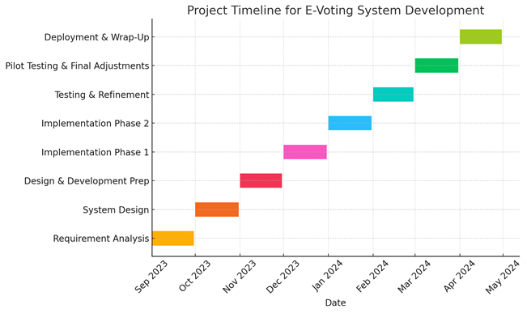
Figure 25:Project Timeline Chart

Appendix IV: Questionnaires
Description:
Questionnaires are structured sets of written questions designed to collect quantitative and qualitative data from respondents. They are suitable for reaching a large sample size and can reveal general opinions and system expectations from potential users and stakeholders.
Preparation:
- The questionnaire was divided into sections including demographic information, current voting experience, concerns with traditional voting, digital literacy, and preferences for online voting features.
- Both closed-ended (e.g., Likert scale) and open-ended questions were used to balance structure and insight.
Administration:
- Distributed physically in public institutions (e.g., universities, public offices) and digitally through email and social media platforms.
- A total of 100 questionnaires were shared, targeting voters, polling officers, and ICT staff from IEBC.
- Responses were collected over a period of two weeks and then analyzed statistically.

Appendix V: Interviews
Description:
Interviews provide a direct way to interact with stakeholders, allowing for deeper exploration of user needs, concerns, and expectations. They help uncover tacit knowledge and system requirements that might not emerge in written surveys.
Preparation:
- A semi-structured interview guide was developed with open-ended questions focused on system usability, trust in digital elections, and perceived barriers.
- Questions also covered security preferences, accessibility features, and anticipated challenges.
Administration:
- Conducted face-to-face and via virtual calls (Zoom/Google Meet) with selected participants including:
  - IEBC officials (2)
  - ICT professionals (2)
  - Voter representatives (3)

Appendix VI: Observation
Description:
Observation involves directly watching how users interact with current systems or environments to identify gaps, pain points, and behaviors that inform design.
Preparation:
- A checklist was prepared to guide what aspects to observe during ongoing electoral registration or mock voting exercises.
- Focus areas included user flow, time taken per user, security verification steps, and support offered to voters.

Administration:
- Observations were carried out at IEBC voter registration centers.
- Researchers noted how voters interacted with clerks and handled the verification process.
- Insights were documented anonymously and were later used to design user-friendly and accessible interfaces for the new system.

